# **1.0 Login**

To log in as an Administrative user, click on the "Administrative Login" button located on the top right corner of the GRS homepage. This will redirect you to the login page (similar to Fig-1.1). Enter your user ID/username and PIN number accurately, and click on the login button. If the details are correct, you will be redirected to your complaint list page. Otherwise, a warning message will appear on the screen.

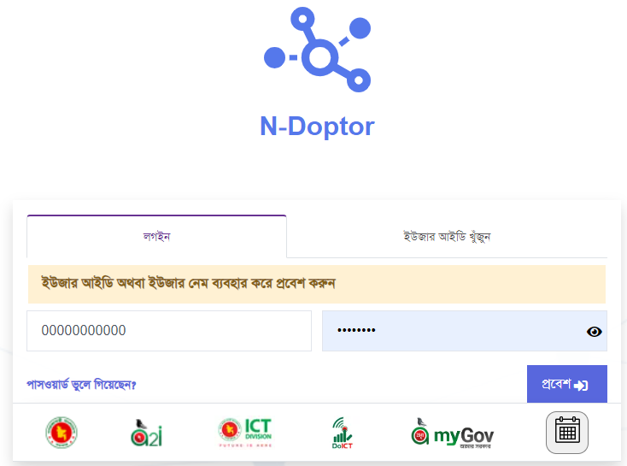

**Figure-1.0: Login form**

If you are already logged in, instead of seeing the login buttons on the homepage, you will find buttons labeled "My Panel" and "Logout." Clicking on the "My Panel" button will take you to your Administrative list page.

Please note that registration for Administrative users is not available. The GRS system requires Administrative users to provide their office ID and password for login. The GRS system collects Administrative user office data through the API gateway.

## **1.1 Search User ID:**

If you forget your User office ID/User name, click on the "Search user ID" option located above the administrative login form. Enter your User NID correctly, and a new PIN code will be sent to the Mobile/Email address provided during user account registration. You can then easily log in using the new User ID.

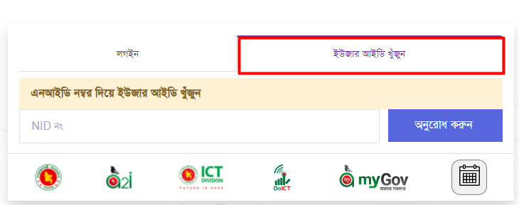

**Figure-1.1: Search User Id form**

## **1.2 Forgotten Pin code (Change PIN):**

If you forget your PIN number or wish to change it, click on the "Recover PIN" option below the login form. Enter your Username/User ID correctly and choose either the email or mobile number option to receive a new PIN code. The new PIN code will be sent to the provided number or email. You can then easily log in using the new PIN.

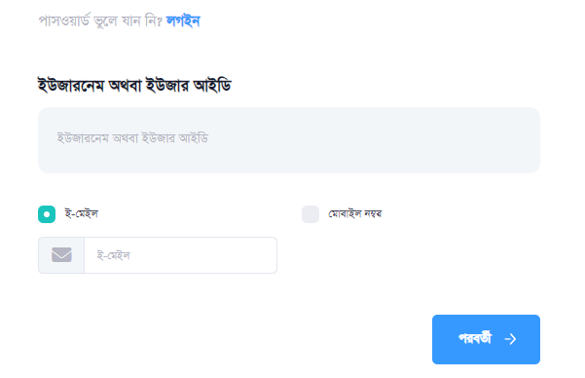

**Figure-1.2: Password recovery**

## **1.3 Logout:**

After logging in, you can log out by clicking on your username displayed on the top menu bar. An option labeled "Logout" will appear. Click on that option to log out of your current session. Alternatively, a "Log Out" button will be available on the homepage while you are logged in. Clicking on that button will also log you out. Once properly logged out, you will be redirected to the GRS homepage.

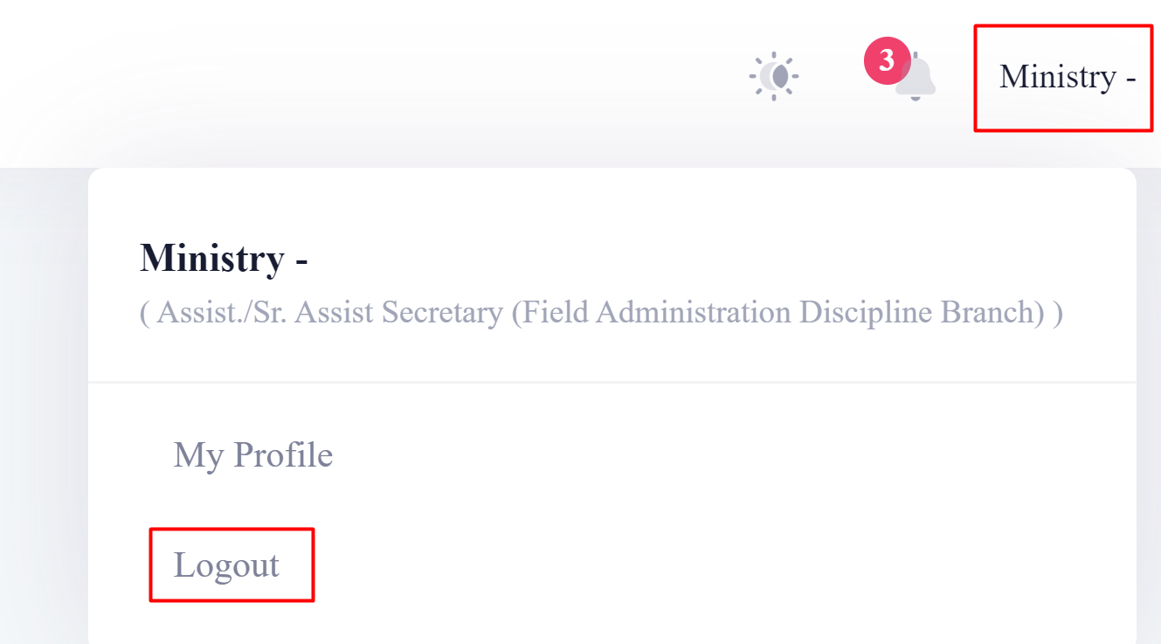

**Figure-1.3: User Logout**

Once logged into the system, the user will stay on the Dashboard page. On the top of the Dashboard page, the user can view a menu in the middle top bar. Clicking on the menu bar will display a list of Modules and Submodules described below:

# **2.0. Setup office**

Clicking on the "Setup Office" menu from the menu bar will take you to a new page where you can view the options for setting up Appeal officers, Grievance Redressed officers, and office admin.

## **2.1 Setup officer for the specific office:**

To set up an officer, click on the "Edit" option under the "Officer" field from the right side of the setup office page. A new page will appear where you can select the office type and view a list of employees with detailed information.

From the employee list, under the "Select Officer" column, you can find a "Select" button. Clicking on the "Select" button will open a new page where you can find "Confirm" and "Cancel" buttons.

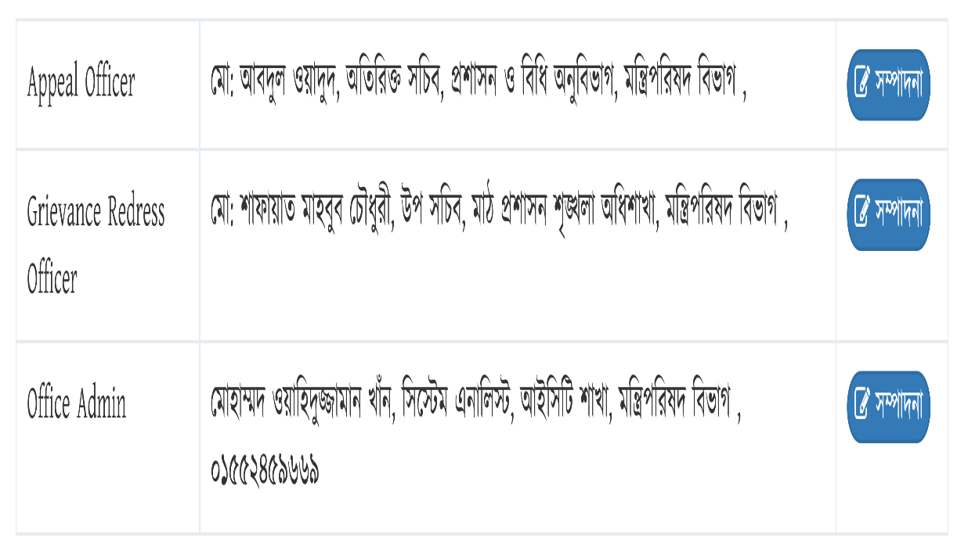

**Figure-2.1: officer list**

**Confirm:** Clicking on the "Confirm" button from the pop-up menu will assign the officer to the specific office.

**Cancel:** Clicking on the "Cancel" button from the pop-up menu will close the pop-up window.

Customize Citizen Charter:

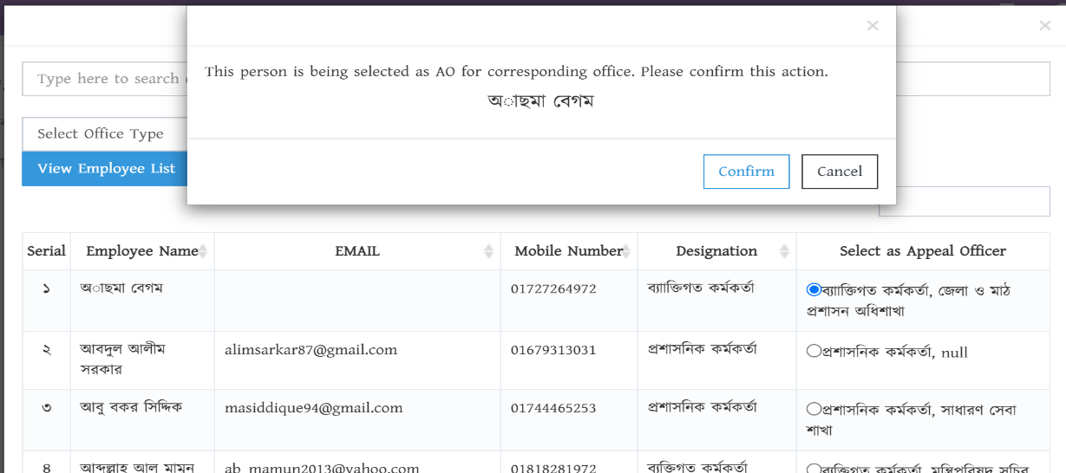

**Figure-2.1.1: Setup officer for specific office**

**2.2 Customize Citizen Charter:-**  
From the setup office page, you can view a list of Citizen Charters with detailed information such as charter status (active/inactive), citizen charter name, service provide timeline, responsible employee information, and options for editing and viewing details.

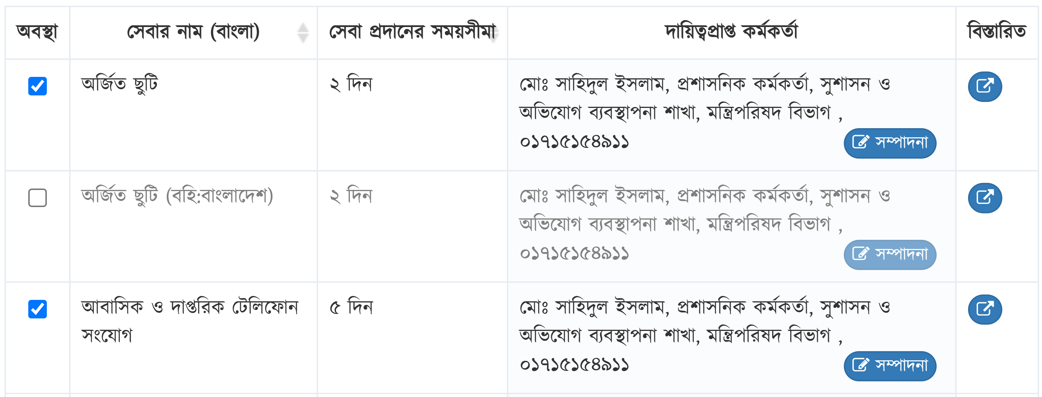

**Figure-2.2: Customize Citizen Charter**

**Change Citizen Charter Status** - In the Citizen Charter list, you can view the citizen charter status in the first column along with a checkbox. If you want to activate a citizen charter, select the checkbox in the status box. If you want to deactivate a citizen charter, uncheck the checkbox in the status box.

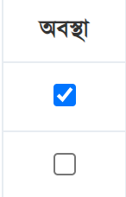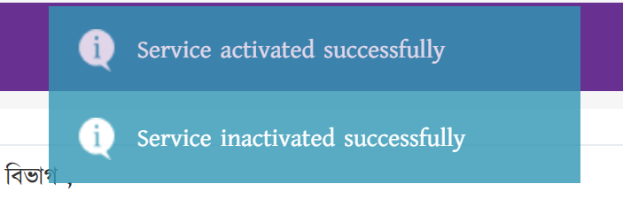

**Figure-2.2.1: Change Citizen Charter**

**Edit Citizen Charter:** user can click editing under citizen charter list from the right side of the setup office page. Where the system will appear a new page where user get select of type office and view employee lists with details information.

From the employee lists under of select officer column user can view select button, after clicking on the select button the system appear a new page where user can view confirm and cancel button.

**Confirm:** - Clicking on the confirm Confirm button from the pop-up menu then the user assign as a responsible employee for this service

**Cancel:** Clicking on the Cancel button on the cancel button from the pop-up menu then the pop up menu will close.

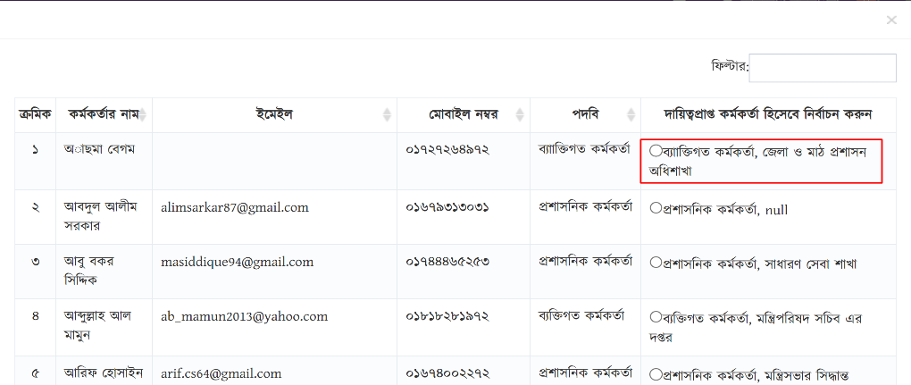

**Figure-2.2.2: Edit Citizen Charter**

**View Details Service list:**

Clicking on the Details button from the right side of the Citizen Charter list, the system appear a new page where user can view details Service list.

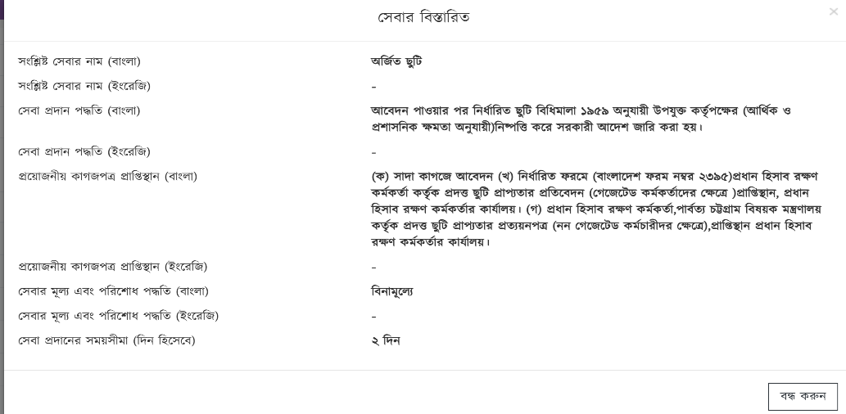

**Figure-2.2.3: View Details Service list**

# **3.0 Sub Office Setup**

Clicking on "Sub Office Setup" from the menu bar will expand three modules under the sub office setup. These modules are described below:

## **3.1 Upload Citizen Charter:-**

Clicking on "Upload Citizen Charter" will open a new page where you can upload citizen charters. Firstly, select the office name from the office type field to add a citizen charter. Then, fill in the required fields. The admin user can download the upload Excel file format from the top right side of the page. Finally, click the "Upload Excel File" button to upload the Excel file and click the "Upload Citizen Charter" option at the bottom right of the page.

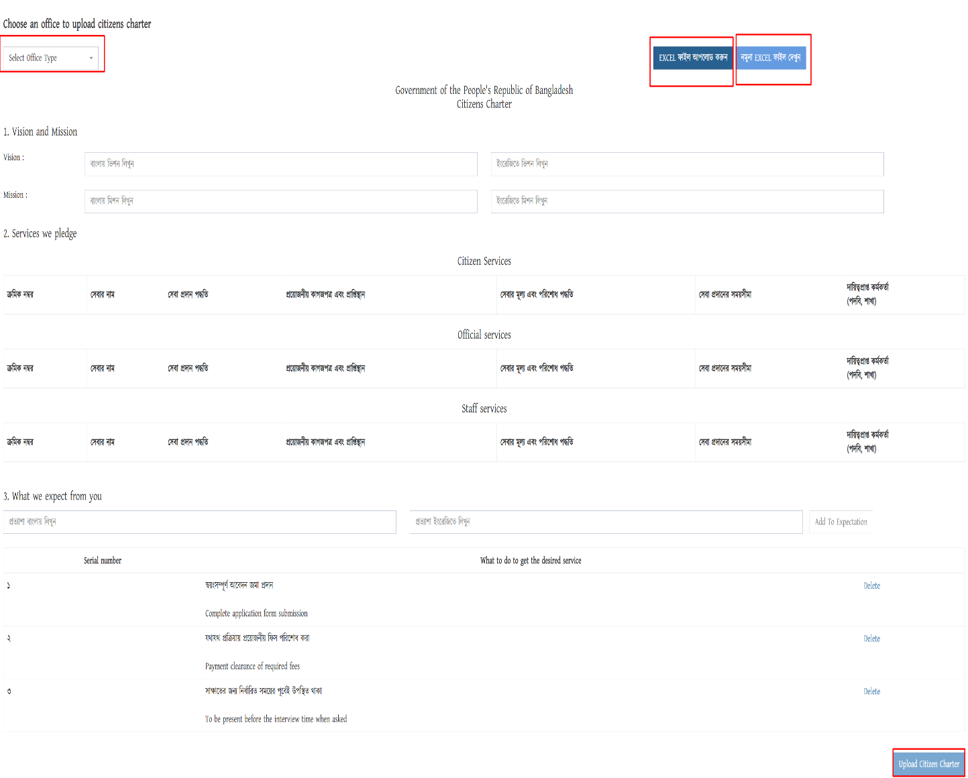**Figure-3.1: Upload Citizen Charter**

## **3.2 Setup Citizen Charter:**

Clicking on "Setup Citizen Charter" will open a new page where you can set up citizen charters. The setup Citizen Charter page displays the select office type field. After selecting an office, you can view the existing citizen charter list for that office with detailed information. You can also change the citizen charter status, edit the citizen charter, or delete the citizen charter for that office.

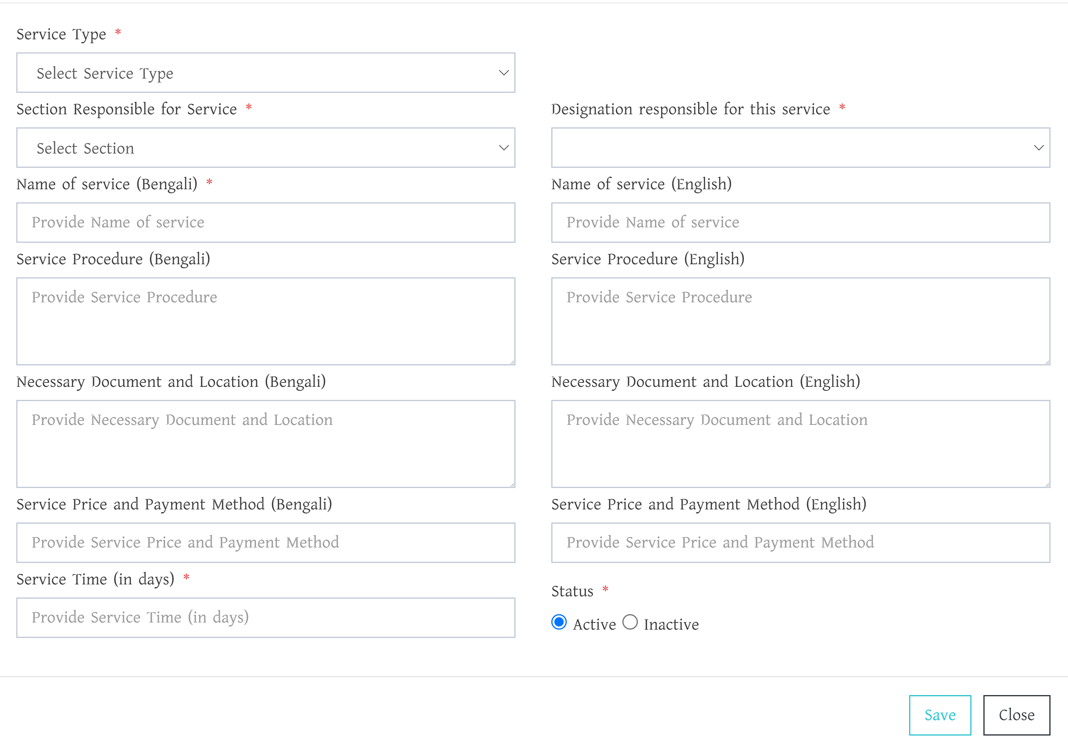 **Figure-3.2: Upload Citizen Charter**

**Add Service:** - Below the add citizen charter page user can view add citizen charter button, Clicking on the Add Citizen Charter button system appear a new page where user can add manually Citizen charter by fill-up require field als0 user can define active or inactive service list when add new service.

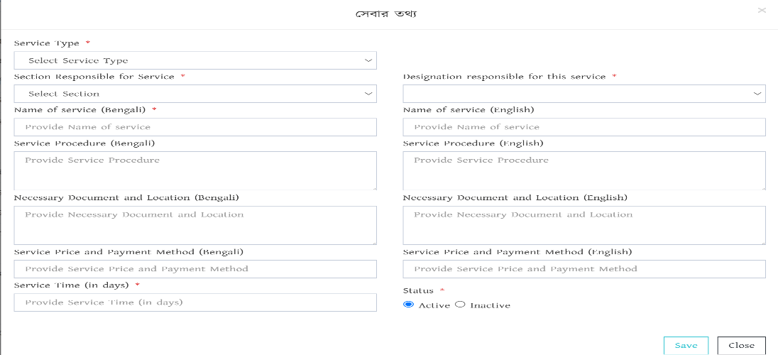

**Figure-3.1.1: Add Service form**

**Figure-3.2.1: Add Citizen Charter**

## **3.3 Office Setup at GRS:**

Clicking on the Office Setup at GRS from the system, the system appear a new page where user can view Select office type and Select the office from this field then User can setup office or office removal right side of the system. After click setup office the system appear officer list and Citizen Charter with details information, also User can edit officer and citizen charter from this page.

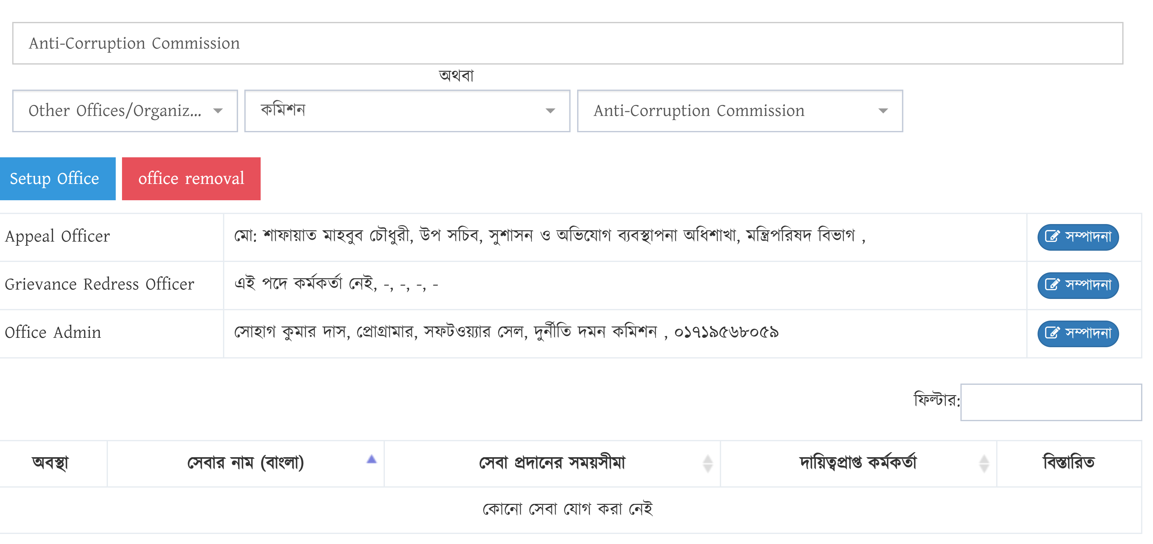

**Figure-3.3: Office Setup at GRS**

# **4.0 Grievance Submitted by You:**

After Clicking on the Grievance Submitted by You the System appear a new page, where user can see a list of grievances filed by you (Figure 4.1). The list displays the most recently filed complaints, usually up to 10. To view other Grievance, use the navigation options below the list.

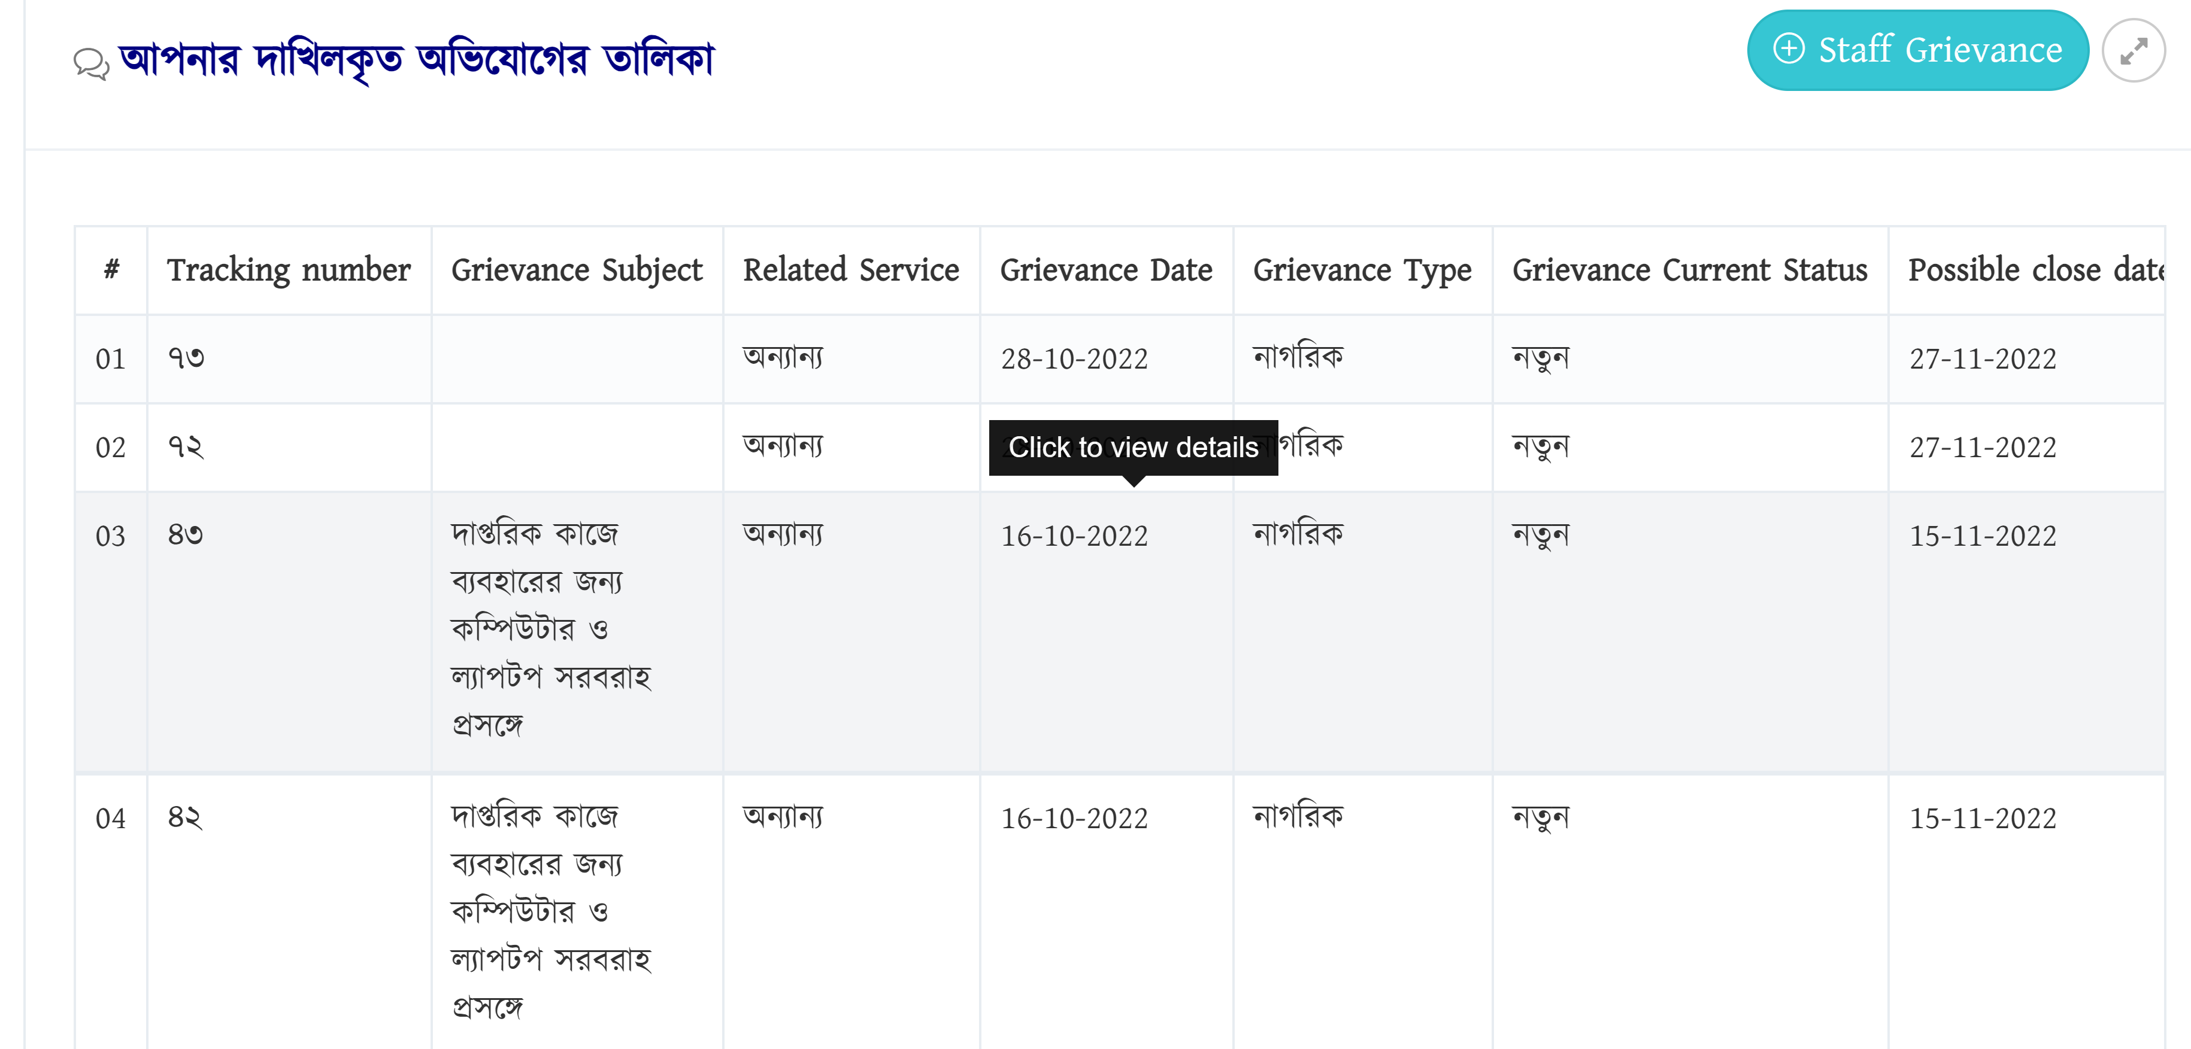

**Figure-4.0: Grievance Submitted list**

## **4.1 Details of complaint**

To view the details of a specific complaint, click on the relevant complaint information from the list. This will open the complaint details section (similar to Figure 4.2). Here, you can find information about the complainant, service details, complaint description, tracking number, latest status, attached files, and other relevant information. You can also print the complaint details if needed.

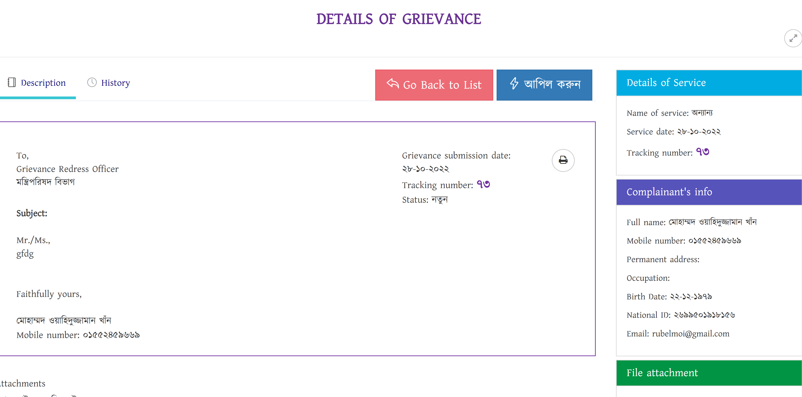

**Figure-4.1: Details of complaints**

**History:**-All the steps taken since filing the Grievance till now can be seen by clicking on **history button** part as shown in Figure-4.1.1.

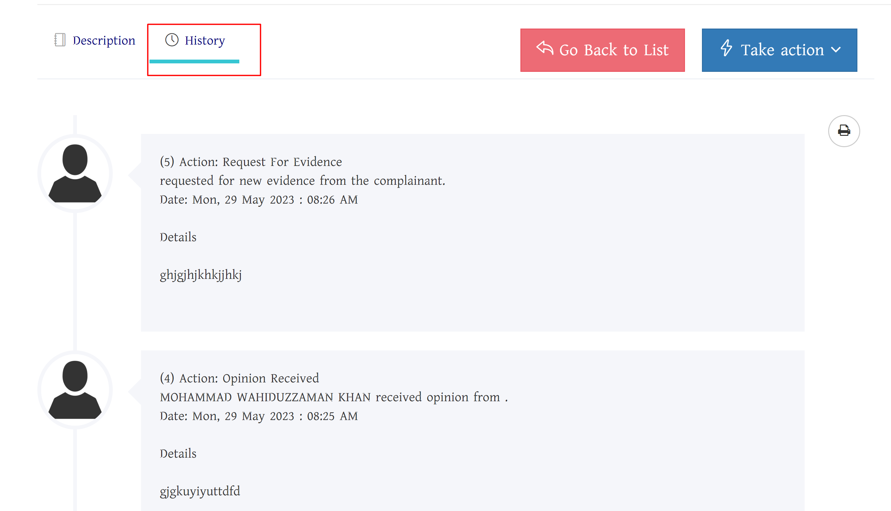

Figure-4.1.1: **Some steps taken in grievance redressed process**

## **4.2 Appeals**

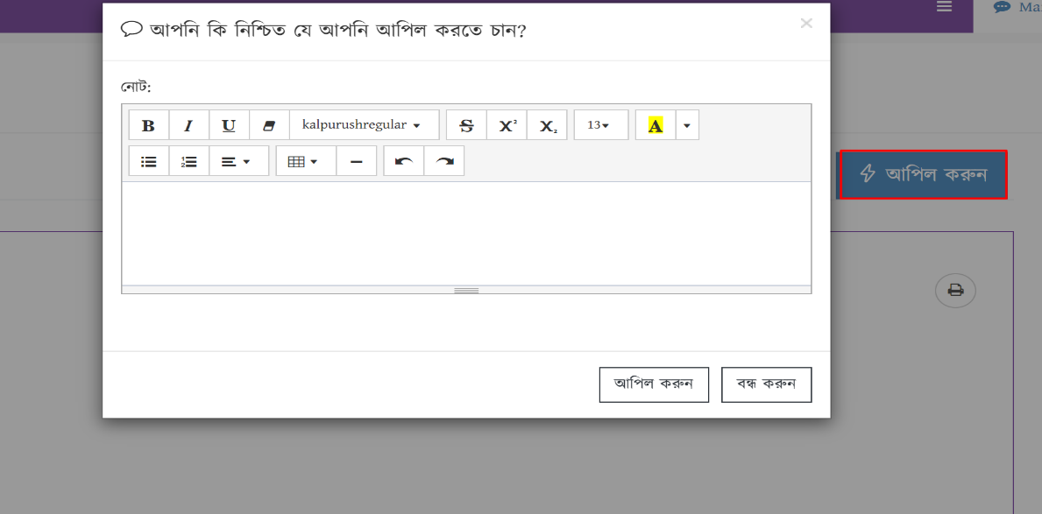Once your submitted complaint is resolved, you will receive notifications through SMS and email. If you are dissatisfied with the action taken by the Grievance Redressed Officer, you

**Figure-4.2: Appeal button form**

You can appeal even if your complaint has been recorded for any reason. To appeal, click on the "Appeal" button located on the right side above the details of the complaint (Figure 5.1). Your appeal will be automatically sent to the concerned Appellate Officer, and you will be provided with the details of the Appellate Officer. The deadline for completing the appeal process is **30 days**.

## **4.3 Complaints and Appeals along the Cell**

If you want to file a complaint with the Cell, select "Cell" in the office selection section when filing the complaint. Your complaint will be directly submitted to the Cell. In case of re-appeal, your appeal will also be forwarded directly to the Cell. The time limit for handling complaints by the Cell is **90 days**, and for appeals, it is **30 days**.

# **5.0 Staff Complainant**

To file a Staff complaint, log in to the complaint redressed system and click on the **"Staff Complainant”** button on the menu list page. This will open a form, in the complaint submission form, select the concerned department and service, enter the date of service application, your name, subject of the complaint, description, and attach necessary files. Finally, click on the "Submit Complaint" button to send the complaint to the complaint resolution officer of that department. Before submission, you can preview and print the complaint. Once successfully sent, a receipt will be displayed with the tracking number of the complaint.

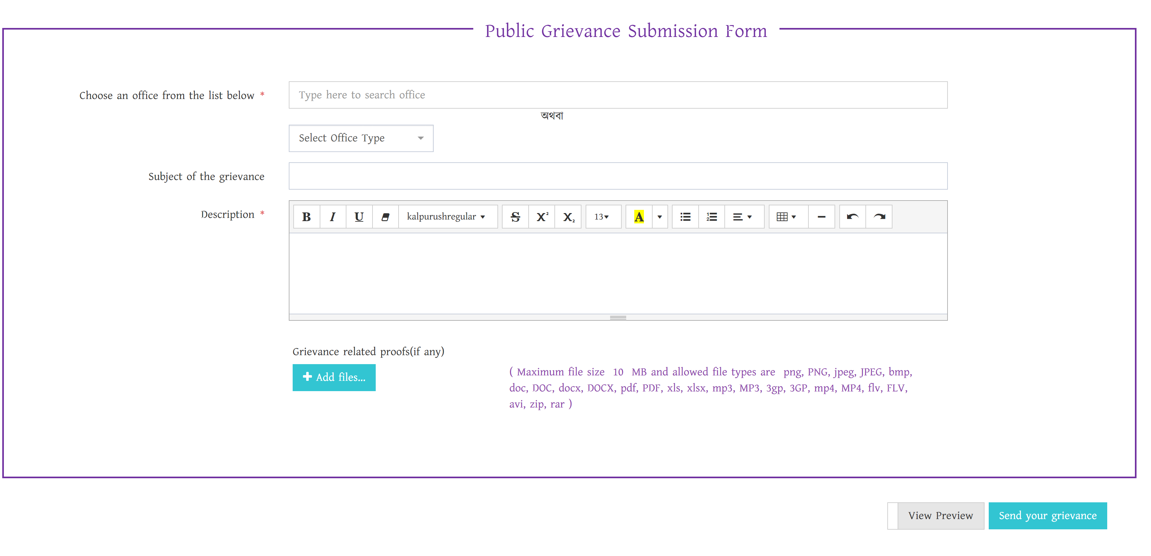

**Figure-5.0: Staff Complainant form**

Note: Save the tracking number to track the progress and latest status of your complaint. The complaint handling time limit is **60 days.**

# **6.0 Notification Button:**

Clicking on the Notification menu from the task bar on the admin user home page. The system will appear new pop-up, there user can view notification list with some information and clicking on the notification from the notification list user will view details information.

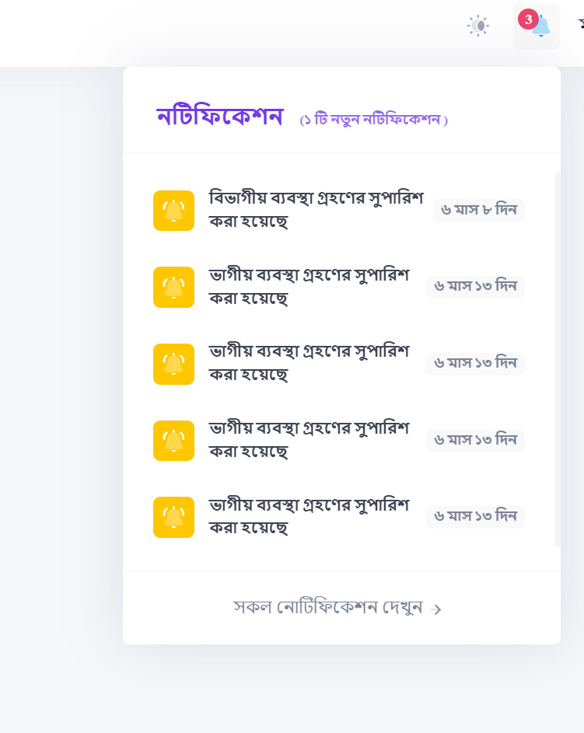

**Figure-6.0: Notification button**

# **7.0 Profile Management**

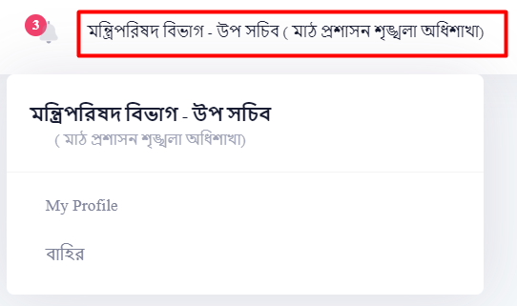Clicking on “My Profile” as indicated in Figure-1.3 will take you to the page. There User can update your profile as an (OISF) user.

**Figure-6.0: Profile Management**